UBIFS bring up:
UBIFS may be considered as the next generation of the JFFS2 file-system.
UBIFS works on top of UBI volumes and cannot operate on top of MTD devices. In other words, there are 3 subsystems involved:
- MTD subsystem, which provides uniform interface to access flash chips. MTD provides an notion of MTD devices (e.g., /dev/mtd0) which basically represents raw flash;
- UBI subsystem, which is a wear-leveling and volume management system for flash devices; UBI works on top of MTD devices and provides a notion of UBI volumes; UBI volumes are higher level entities than MTD devices and they are devoid of many unpleasant issues MTD devices have (e.g., wearing and bad blocks); see here for more information;
- UBIFS file system, which works on top of UBI volumes.

For more information on UBI, refer <http://www.linux-mtd.infradead.org/doc/ubi.html>
For more information on UBIFS, refer <http://www.linux-mtd.infradead.org/doc/ubifs.html>

Linux kernel configuration:

Step1:
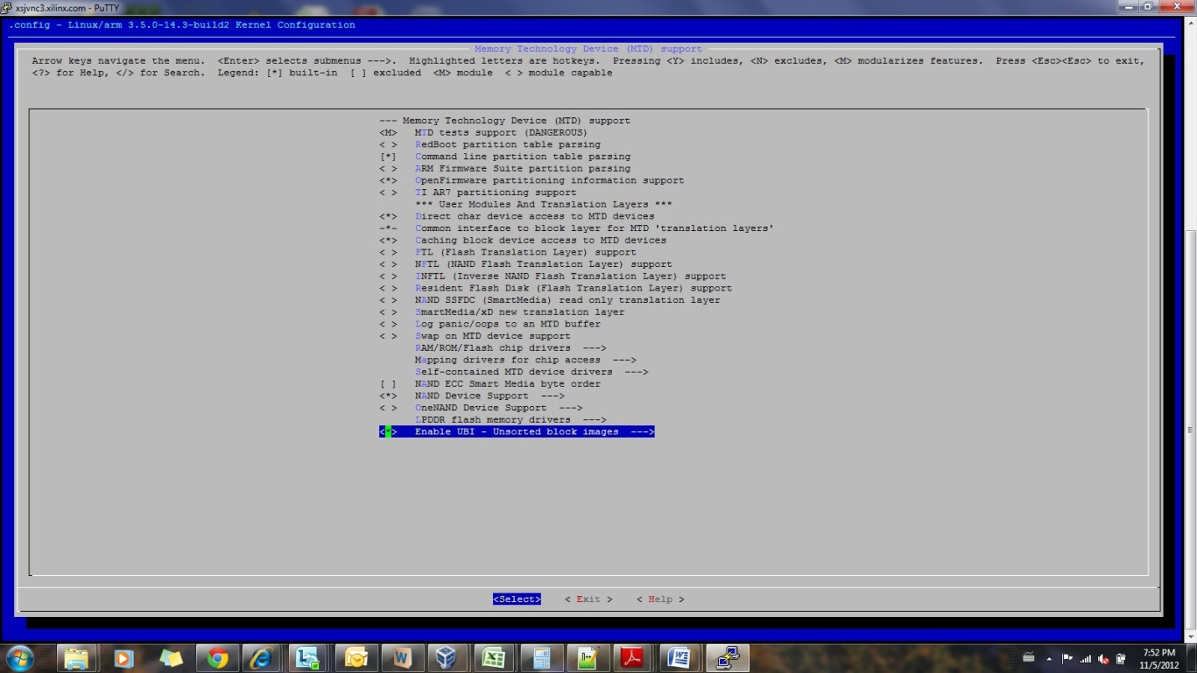

Step 2:
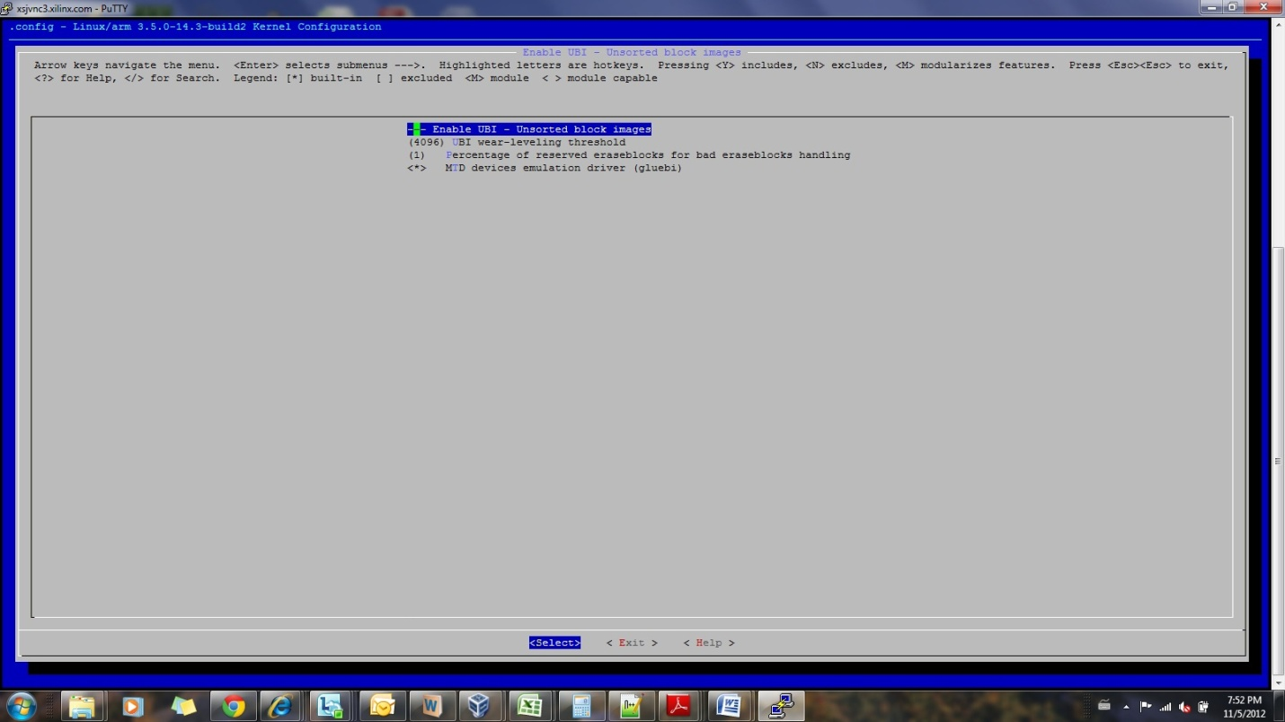

Step 3:
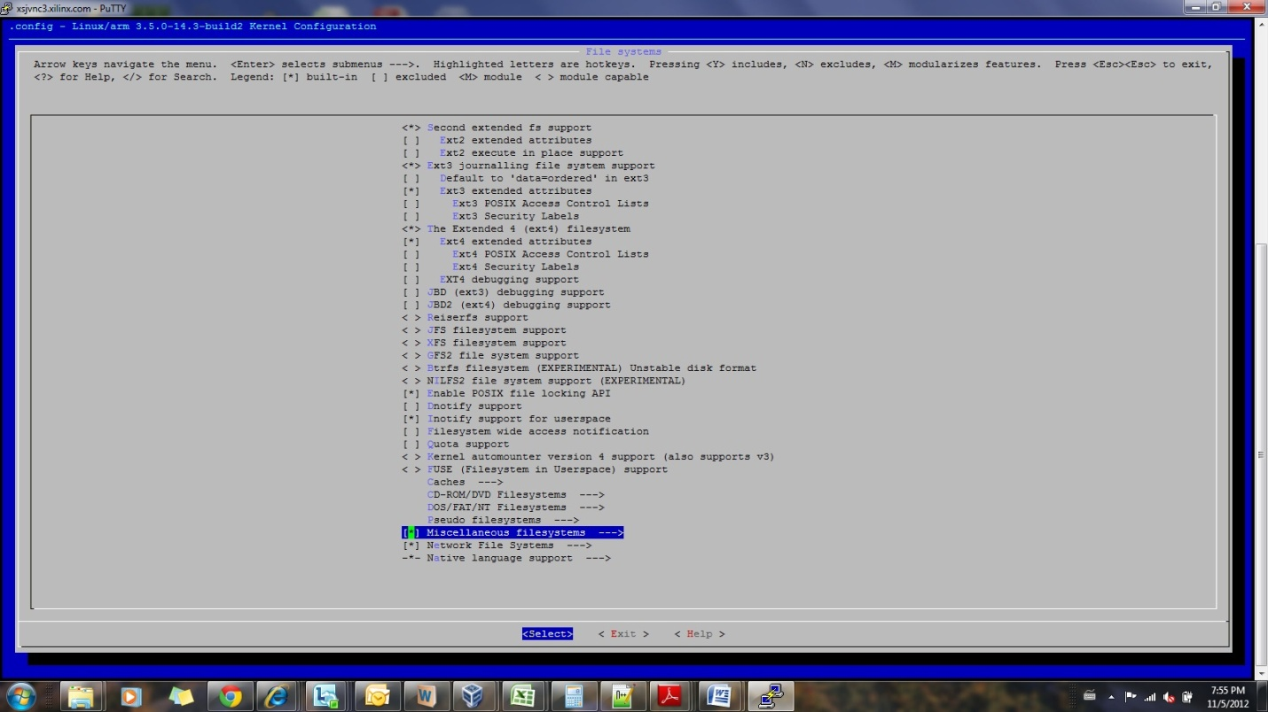

Step 4:
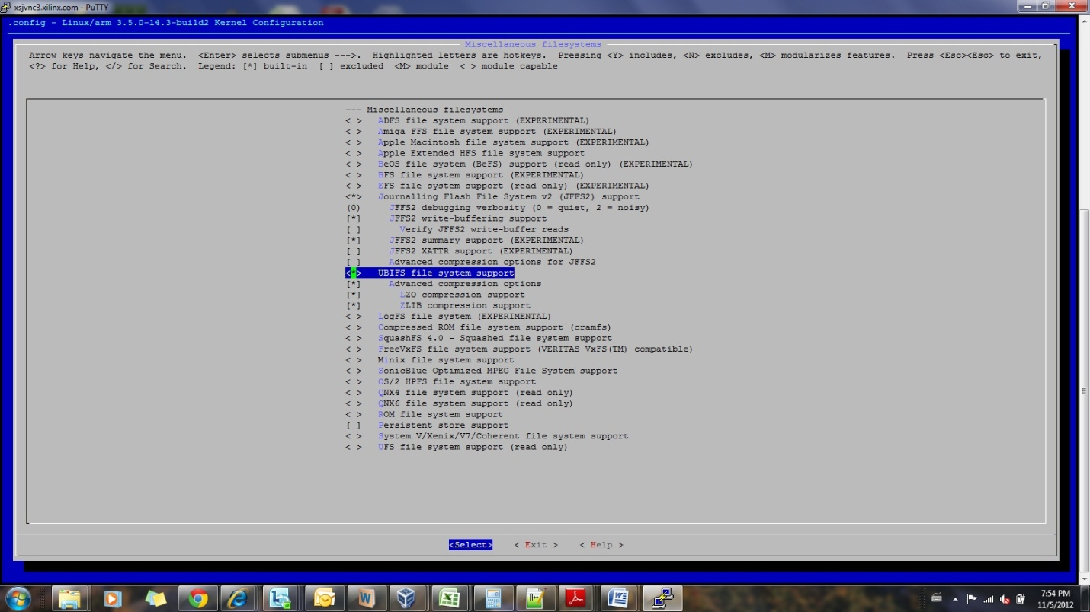

User Space Tools:
For more information on MTD, refer <http://www.linux-mtd.infradead.org/doc/general.html>
For more information on UBI, refer <http://www.linux-mtd.infradead.org/doc/ubi.html>
For more information on UBIFS, refer <http://www.linux-mtd.infradead.org/doc/ubifs.html>

UBI user-space tools, as well as other MTD user-space tools, are available from the the following git repository: git://git.infradead.org/mtd-utils.git
The repository contains the following UBI tools:
ubinfo - provides information about UBI devices and volumes found in the system;
ubiattach - attaches MTD devices (which describe raw flash) to UBI and creates corresponding UBI devices;
ubidetach - detaches MTD devices from UBI devices (the opposite to what ubiattach does);
ubimkvol - creates UBI volumes on UBI devices;
ubirmvol - removes UBI volumes from UBI devices;
ubiupdatevol - updates UBI volumes; this tool uses the UBI volume update feature which leaves the volume in
"corrupted" state if the update was interrupted; additionally, this tool may be used to wipe
out UBI volumes;
ubicrc32 - calculates CRC-32 checksum of a file with the same initial seed as UBI would use;
ubinize - generates UBI images;
ubiformat - formats empty flash, erases flash and preserves erase counters, flashes UBI images to MTD devices;
mtdinfo - reports information about MTD devices found in the system.
All UBI tools support "-h" option and print sufficient usage information

Compiling UBIFS Tools
The MTD and UBI user-space tools are available from the following git repository:
git://git.infradead.org/mtd-utils.git
Dependencies
The 'mtd-utility' requires zlib, lzo and uuid (from e2fsprogs) libraries. The former two are used for compressing the data, and the latter one is used for generating universally unique ID number for the file-system.
- zlib
- lzo
- e2fsprogs

Sources
zlib
Download zlib from http://zlib.net/
lzo
Download from http://www.oberhumer.com/opensource/lzo/download/ .
e2fsprogs
Download e2fsprogs from http://e2fsprogs.sourceforge.net/

zlib
tar -xzf zlib-1.2.7.tar.gz
cd zlib-1.2.7/
./configure --prefix=$INSTALLDIR/install
host$ vi Makefile
CC=arm-xilinx-linux-gnueabi-gcc
LDSHARED=arm-xilinx-linux-gnueabi-gcc -shared -Wl,-soname,libz.so.1,--version-script,zlib.map
CPP=arm-xilinx-linux-gnueabi-gcc -E
AR=arm-xilinx-linux-gnueabi-ar
RANLIB=arm-xilinx-linux-gnueabi-ranlib
Make
Make install

Lzo
tar -xzf lzo-2.06.tar.gz
cd lzo-2.06
export CC=arm-xilinx-linux-gnueabi-gcc
root@ lzo-2.06# ./configure --prefix=$INSTALLDIR/install --host=arm-xilinx-linux-gnueabi
make
make install

e2fsprogs
tar -xzf e2fsprogs-1.42.tar.gz
cd e2fsprogs-1.42
export CC=arm-xilinx-linux-gnueabi-gcc
root@ /lzo-2.06# ./configure --prefix=$INSTALLDIR/install --host=arm-xilinx-linux-gnueabi
make
make install
cd lib/uuid/
make install

mtd-utils
tar -xvf mtd-utils-1.4.9.tar.bz2
MTD-Utils don't have a configure script, so we have to edit Makefile again. Depending on the version of MTD Utils, make sure head of top level Makefile has:
cd mtd-utils-1.4.9
root@/mtd-utils-1.4.9$ vi Makefile

PREFIX = $INSTALLDIR/install
CROSS=arm-none-linux-gnueabi-

ZLIBCPPFLAGS = -I$(PREFIX)/include
ZLIBLDFLAGS = -L$(PREFIX)/lib

LZOCPPFLAGS = -I$(PREFIX)/include
LZOLDFLAGS = -L$(PREFIX)/lib

LDFLAGS += $(ZLIBLDFLAGS) $(LZOLDFLAGS)
CFLAGS ?= -O2 -g $(ZLIBCPPFLAGS) $(LZOCPPFLAGS)
Edit the common.mk file and comment out the PREFIX=/usr line
root@/mtd-utils-1.4.9$ vi common.mk
#PREFIX=/usr
root@/mtd-utils-1.4.9$ WITHOUT_XATTR=1 make
root@/mtd-utils-1.4.9$ make install DESTDIR=$INSTALLDIR/install

How to Run:

Erase your flash partition while preserving your erase counters:
ubiformat /dev/mtdx
here ‘x’ is the mtd partition number
Attach UBI to one (of several) of the MTD partitions:
ubiattach /dev/ubi_ctrl ­m x
Volume creation with ubimkvol:
ubimkvol /dev/ubi0 ­N test ­s 116MiB
(or)
ubimkvol /dev/ubi0 ­N test ­m (max available size)
When a UBI volume is created, creating an empty UBIFS:
filesystem is just a matter of mounting it
mount ­t ubifs ubi0:test /mnt/flash

Benchmark Tools
- Bonnie++
- Iozone

